**GENERAL INTEGRATED SCIENCE – UNIT 2**

**TASK 13 – Force, Energy and Motion test**

**WEIGHTING: 5 %**

**NAME: _________________________________**

**DATE: _________________________________ MARK: _____ / 55 = ______ %**

Important Information for Students

1. There are TWO sections in this test - Multiple Choice and Short Answer.
2. This is a closed-book assessment (no notes are allowed)
3. The time allowed to complete the test is 55 minutes.
4. Write your answers to the Multiple Choice section on the **separate** answer sheet provided.
5. Write your answers to the Short Answer section in space provided.

|  |  |  |
| --- | --- | --- |
| Sections | **Marks Allocation** | **Your Total** |
| **A - Multiple Choice** | 20 |  |
| **B - Short Answer** | 35 |  |
| **TOTAL** | **55** |  |

**Multi choice**

1. What is the push or pull on an object that can cause it to accelerate called?
2. Mass
3. Force
4. Density
5. Speed
6. What is the unit of measurement for force?
7. Amp.
8. Seconds.
9. Newtons.
10. Joules.
11. What is the sum of all the forces acting on an object called?
12. Gravity
13. Reaction force.
14. Acceleration.
15. Net force.
16. In a tug of war, team A is pulling with a force of 100N and Team B with a force of 80N, what will happen?
17. Neither team will move.
18. Team A will go forwards with a force of 100N.
19. Team B will go backwards with a force of 20N.
20. Team B will go forwards with a force of 20N.
21. What do you multiply mass by to get weight?
22. Gravity.
23. Speed.
24. Density.
25. Energy.
26. What will be the difference on the moon than on earth?
27. Mass.
28. Weight.
29. Both a and b.
30. None of the above.
31. Which of Sir Isaac Newtons’ Laws of Motion applies to the rocket while in flight?
    1. First (the law of inertia).
    2. Second (the greater the mass, the greater the force required to accelerate it).
    3. Third (for every action there is an equal and opposite reaction).
    4. Fourth (gravity may be defeated).
32. If the gravity on the moon is 1/6th that on Earth, (take Earth’s gravity as 10ms-2), what would be the weight of a man on the moon if on earth he has a weight of 1000N?
33. 1000N
34. 500N
35. 600N
36. 166N

**Questions 9 – 13** refer to the following information:

Sophie conducted an experiment about rocket flight. She constructed three water-bottle rockets, each from an empty 2L soft-drink bottle, and each with five identical fins. She filled the rockets with varying amounts of water and launched each rocket once after increasing the air pressure to 40 psi. Her results are found in the table below.

|  |  |  |
| --- | --- | --- |
| **Rocket** | **Amount of water (ml)** | **Maximum altitude (m)** |
| 1 | 200 | 8 |
| 2 | 400 | 23 |
| 3 | 800 | 37 |

1. The amount of water contained in the water-bottle rocket is the
   1. dependant variable
   2. independent variable
   3. aim of the experiment
   4. unit of measurement
2. The following are some of the control variables in this experiment:
3. bottle size, number of fins, amount of water
4. Fin size, number of fins, air pressure
5. bottle size, wind conditions, mass of bottle
6. number of fins, wind conditions, amount of water
7. The water in the water-bottle rocket is acting as the rockets’
8. fuel
9. thrust
10. lift
11. propellant
12. A fair conclusion that can be made from the results of this experiment is that
13. increasing the number of fins will cause a water-bottle rocket to fly higher
14. a water-bottle rocket that contains less water will fly higher
15. a water-bottle rocket that contains more water will fly higher
16. the quantity of water contained in a water-bottle rocket has no effect on altitude reached
17. Sophie could improve her experiment by
18. conducting repeat trials
19. controlling the mass of the rockets
20. changing the number of fins
21. Both **a** and **b**
22. Which of Newton’s Laws backs up the idea that we must wear seat belts?
23. Newton’s first law.
24. Newton’s second law.
25. Newtons third law.
26. All of the above.
27. Which of the following is NOT a vector quantity?
    1. Velocity
    2. Speed
    3. Acceleration
    4. Force

The following 3 questions are regarding the image below. The diagram shows a cyclist at different positions as he cycles on a humpback bridge.

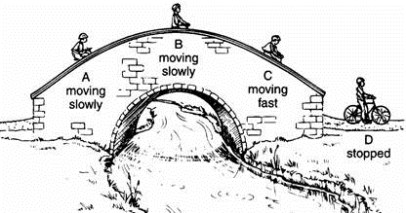

1. Where does the cyclist have the most kinetic energy?
   1. A
   2. B
   3. C
   4. D
2. Where does the cyclist have the most potential energy?
   1. A
   2. B
   3. C
   4. D
3. Where does the cyclist have the least potential energy?
   1. A
   2. B
   3. C
   4. D
4. Which of the following is NOT a form of energy?
   1. Mechanical
   2. Electrical
   3. Chemical
   4. Newtons
5. Which of Newton’s Three laws does the following example illustrate? The blood in your head rushes to your feet when riding on an elevator that is going down and abruptly stops.
   1. Newton’s First Law
   2. newton’s second Law
   3. Newton’s Third Law
   4. All of the above.

**Short Answer section**

**Question one**

1. After playing with their toy, Ashley and James left the car and went away to get a refreshing drink. When they returned, they found the car at the same spot where they left it. Using **one** of Newton’s laws, explain why the car was found at the same spot. (3 marks)

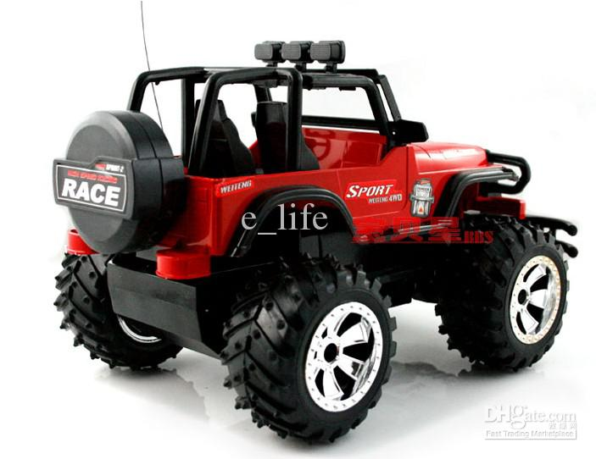

_____________________________________________________________________________________________________________________________________________________________________________________________________________________________________________________________________________________________________________________________________________________________________________

1. After playing with their car for a long time, Ashley noticed that the car was not responding well to the remote control. James replaced the old batteries with brand new ones and the toy began to work again.
2. State the type of energy found in the battery. ______________________ (1 mark)
3. State the energy changes that occur when the toy car is working normally. (2 marks)
4. Explain what is meant by the term wasted energy? (1 mark)

________________________________________________________________________________________________________________________________________________________

1. Imagine that the car battery contains 260 Joules of energy. If the toy car is only 35% efficient, how much useful energy will the car engine produce? (2 marks)

**Question Two**

The diagram below shows to men pushing an 800kg car that broke down. One man applied a pushing force of 275N while the other stronger man pushed with 395N. The force of friction, 560N, opposes the movement of the car.

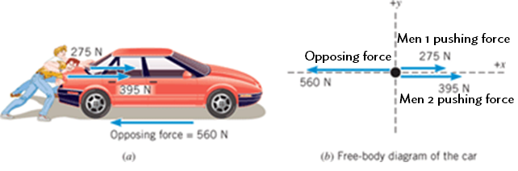

1. Calculate the total force applied by the two men on the car. (1 mark)
2. Calculate the resultant or unbalanced force that actually moves the car while the opposing force acts. (2 marks)

1. Calculate the car’s acceleration [Hint: Newton’s 2nd law] (2 marks)
2. Using the above example, explain the difference between a vector and scalar quantity (3 marks)

**Question Three**

The following diagram shows a rollercoaster ride. The car starts from A and travels to F, where it stops by hitting a bumper. At E, the car enters a trench filled with water. Use the letters to answer the questions.

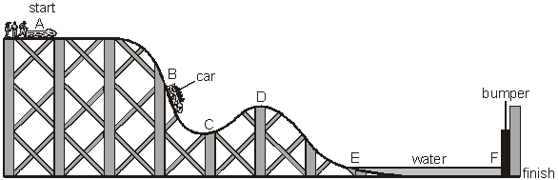

1. At which **TWO** points does the car have **NO** kinetic energy? _________________ (1 mark)
2. At which point does the car have the **MOST** gravitational potential energy? (1 mark)

_____________________

1. At which point does the car have **SOME** kinetic energy and the **LEAST** gravitational potential energy? ______________ (1 mark)
2. The bumper at the end is designed to stop the passengers in the rollercoaster hurting themselves.
3. Which of Newton’s Laws is in action when the rollercoaster hits the bumper? _____ (1 mark)
4. What design feature should the bumper have to reduce the effect this law would have on the rollercoaster. Explain why it works. (2 marks)

________________________________________________________________________________________________________________________________________________________________________________________________________________________________________________________________________________________________________________

1. Justify why there needs to be the moat of water at the end of the ride rather than just the bumper using your knowledge of forces, types of energy and Newton’s Laws. (4 marks)

________________________________________________________________________________________________________________________________________________________________________________________________________________________________________________________________________________________________________________________________________________________________________________________________________________________________________________________________________________________________________________________________________________________________________________________________________________________________

**Question Four**

**Use the following formulas to help answer the following questions**

**Speed = distance/time (v = d/s) Force = Mass x Acceleration (F = ma)**

1. A dog takes 18 seconds to run around a semicircular track of length 72m.

What is the dogs speed? (2 marks)

1. A cyclist travels at a constant speed of 15m.s-1 in a straight line for 15 seconds. She then travels in the same direction at 20ms-1 for another 15 seconds. Calculate her average speed for the whole 30 seconds. (2 marks)
2. A skateboarder is accelerating at 2.5m.s-2. The skateboarder has a mass of 60kg and the board has a mass of 2kg. Calculate the size of the resultant force acting on the rider and the skateboard. (2 marks)
3. The thrust from an outboard engine of a speed boat is 1000N. If the boat has a mass of 500kg and the friction force opposing the motion of the boat through the water is 200N, what is the acceleration of the speed boat. (2 marks)